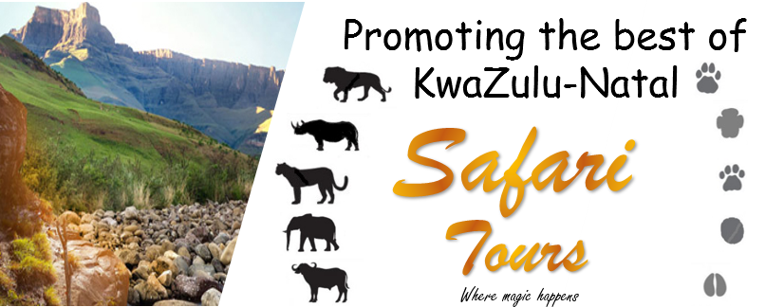

Win a 12-night Luxury Holiday in KwaZulu-Natal, South Africa valued at R65 000.
W

e would really appreciate your thoughts and opinions on travelling to and/or around KwaZulu-Natal. As a special thank you for your time and feedback, Safari Tours has put together a fabulous 12-night holiday around KZN valued at over R65 000 for one lucky couple.
Please share via WhatsApp!


The more you share the more entries you will get in the competition.
Make sure we have your entry as well as the number of shares.
Win! Win! Win!
The good news is that EVERYONE is a winner in this competition, because every entrant will receive a guaranteed R1 000 travel voucher for completing the survey. Terms and conditions apply.
Your feedback will also help ascertain how the various KZN hotels and lodges can serve you better in the future.
You are very welcome to skip any questions you do not feel comfortable answering. However, make sure to enter your personal information for the guaranteed voucher and a chance to win.
Competition form
Personal information
Name Surname
Age Question/Vraag 2.4.1 Nationality
E-mail address Cell Number
WhatsApp shares

Number shared
(Number of shares via WhatsApp)
Extra entries
(For office use ONLY)

What kinds of accommodation do you prefer to use?
Backpackers Self-Catering B&B/Guesthouse
Hotel Lodge Resort
Timeshare Stay with friends and family
What is important for your holiday?
Big 5 Safari | Historic interest | Time with family
Romantic | Adventure packed | Universal access
Pet friendly | Sustainable tourism | Resort facilities
Feedback:
(Provide feedback regarding the service of hotels/lodges)
___________________________________________________________________
___________________________________________________________________
I hereby accept the terms and conditions.

Question/Vraag 2.6
Competition Terms and Conditions
- The competition is open to everyone aged 18 years or above, except:
  - employees of Safari Tours;
  - close relatives of employees; and
  - anyone connected with the organisation, or
  - judges of the competition.
- The prize is valid for 2 people sharing.
- Please note this prize does not include flights, transfers – or any extras not already specified.
- Prize is valid until 15 December 2022.
- Should you wish to extend your stay at any one of the properties, or bring any extra family or friends along with you – a special discounted rate will be offered:
  - Extended stay – 5% discount
  - 5 or more members – 2 extra nights
  - 2 or more members – 1 extra night

